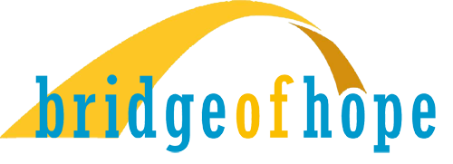

Bridge of Hope 2.0
After 20 years as St Louis’ longest, continuously operating, low barrier, day shelter, and located in the historical Greater Ville neighborhood, Bridge of Hope’s leadership has refocused its mission, strategic plan, and resources to take the next challenging steps of:

- Transforming lives of the homeless in The Ville neighborhood, through professional, supportive services and advocacy, in a safe and secure environment

- Actively participating in the revitalization of the Ville neighborhoods to their historical prominence as St Louis’ preeminent African-American community.

Our strategic direction will:
- Focus on the unhoused and housing insecure in the Ville neighborhoods, known as the Greater Ville
- Tell the compelling story, throughout the St Louis region, of the significance of the African-American Ville community, through the first half of the 20th century
- Articulate the necessity of revitalizing the Ville community to its historical preeminence
- Reduce homelessness in the Ville communities, providing community health and social services
- Provide a safe and secure environment where the homeless can begin to transform their lives
- Build a collaborative, not competitive, network of service providers, non-profits, community advocates and government agencies
- Require a sustained effort, supported by a committed and diverse regional community
- Be an integral part of the collective social and economic revitalization of The Ville communities

Success will look like:
- A safe and secure on-site transitional housing for those who are committed to improving their lives
- Unhoused community members enrolled in and completing supportive service programs, addressing
addiction, mental/physical health, functional education, basic life skills and spiritual strength
- Community members transitioning to a secure housing environment
- Bridge of Hope supportive program’s completion rate greater than 50%
- A government funded low barrier, homeless shelter, operated by Bridge of Hope and a network of committed service providers. Providing basic, humane, temporary relief from the streets and serving as an entry point for the Bridge of Hope’s comprehensive treatment network.
- Region wide community support and commitment to being part of the solution
- Financial commitments to provide program services in 3-year increments

To paraphrase President John F Kennedy, “We choose to do this not because it is easy, but because it is hard, because this goal will serve to organize and measure the best of our energies and skills, because this challenge is one that we are willing to accept, one we are unwilling to postpone, and one which we intend to win.”

